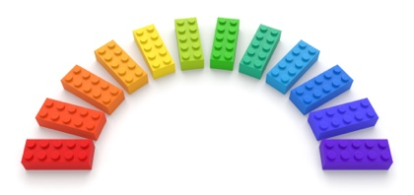

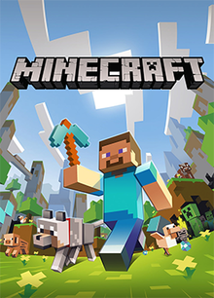

|  |  |
| --- | --- |
| **Task** | **Tick list** |
|  |  |
|
|  |  |
|
|  |  |
|
|  |  |
|
|  |  |
|
|  |  |
|
|  |  |
|
|  |  |
|
|
|

