EY2c Parent Declaration Form
Torpoint Nursery and Infant School Online Version
Please complete the form and return it via the school email secretary@torpoint-inf.cornwall.sch.uk .

Child details
Legal forename | Legal middle name/s | Legal surname
First language | Surname by which child is  known (if different)
Date of birth: | Please indicate: Male Female:
Ethnic origin – these boxes cannot be completed please type your ethnic origin code into the box below 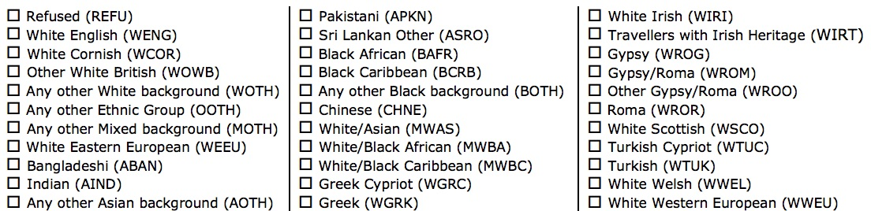
Ethnic Origin code
Address

Postcode
2 year old Application Ref: 908- |  |  | Eligibility date:

Setting and attendance details
My child is claiming the hours below from: …………………………………………….. (date)
Setting Name | Enter total funded hours attended per day |  |  |  |  | Universal hrs per  week | Extended hrs per  week | Please indicate the pattern of attendance  Term time  Banked *  Stretched  If stretched, no. of weeks per year:
 | Mon | Tue | Wed | Thur | Fri

* Banked hours – complete the boxes below
In special circumstances, where stretched funding is not applicable, a few hours a week can be ‘banked’ to give flexibility to the parents. These hours must be used up within a reasonable time and will be reclaimed if not used. Eg. 15 hours a week claimed, 13 hours attended with 2 hours banked a week, so in a 10 week term this will accrue 20 hours to be used up, usually in holiday periods. Careful consideration must be given to ensure these hours will be used up and by when.
Hours banked per week: |  | Date by which banked hours will be used:

My child also attends the following other setting/s: |  | Universal hrs | Extended hrs
Setting name | Total funded hours per week:
Please ensure that the total funded hours do not exceed 15 hours (or 30 if eligible)
02/2019

Carer details for Early Years Pupil Premium
If you believe that your child may qualify for EYPP, please provide the following information regarding the main benefit holder to enable the local authority to confirm eligibility:
Title | Legal forename |  | Legal surname
Male □ Female □ | Date of birth |  | Relationship
Parental responsibility  Yes/No |  | Parent/carer  National Insurance No NASS No.
OR state criteria if other than financial:

I enclose a copy of the supporting document □
Does applicant live at same address as child?  Yes/No |  | If No give applicant’s address:

Additional details for children claiming extended (30) hours funding
Parent/carer National Insurance no. |  | 30 hours eligibility code
Code issue date | Note: Extended hours funding starts the term AFTER the code issue date, and the term AFTER the child turns 3

Privacy Statement
This information is being collected by the Education and Early Years Nursery Funding Team on behalf of Cornwall Council as Data Controller to assess entitlement to receive Nursery education (funded early learning) and other pupil benefits such as the Pupil Premium which can be claimed from the Department for Education to support your child at school. Data on you or your child may also be shared with relevant partners including the Family Information Service, Children’s Centres, Schools, The NHS, Childcare providers and other relevant partners within the Children, Schools and Families Directorate. The data held relating to the delivery of support by the relevant Support Service to your child will be used both for the provision of services and also for performance and service planning. This information will be held in a secure environment in accordance with Cornwall Council retention policy. http://www.cornwall.gov.uk/council-and-democracy/data-protection-and-freedom-ofinformation/data-protection/retention-and-disposal/ after which time it will be destroyed in a secure manner.

A copy of our Privacy Notice can be found at www.cornwall.gov.uk/csfprivacynotice . You have the right to withdraw consent to the processing of your data at any time and your further rights as to how we handle your data can be found by following the above link. Should you wish to withdraw your consent please contact the Nursery Funding Team nurseryfunding@cornwall.gov.uk .

Parent/Carer/Guardian with legal responsibility | Childcare Provider
I agree that my child will attend regularly and I understand that the funding will be withdrawn if this is not the case  Signature _________________________  Print name _________________________  Date _________________________ | Signature _______________________  Print name _______________________  Date _______________________
At the current time, while you are unable to sign the form receiving this from your email will act as your consent and agreement

For completion by setting. THIS SECTION MUST BE COMPLETED TO RECEIVE FUNDING

Type of documentary proof of Child’s DoB (eg Birth Certificate, Passport)
Reference number of proof
Date document recorded
Document recorded by (name of staff member)
Previously

provided on:

date

02/2019

