Schools have a written home-school agreement which we sign and we ask all parents to sign to identify ways we have agreed to work together.
You may want to talk about this agreement with your child by looking at the ideas from our children within the leaflet. If you are able to print this you can then invite them to sign this agreement.

Home-School Agreement
for (child’s name)

The school will work with parents and children to help ensure that each child is able to achieve their potential in all areas.

Signed on Behalf of Torpoint Nursery and Infant School by

Danielle Kellond

As parent/carer we will work with the school to promote positive behaviour and attitudes to learning and school. This will include supporting our child with reading and other homework. We recognise that regular attendance is very important to our child’s education.

Signed by
Date

As a child I agree to do my best and always be kind and caring to others in school.

Signed by

Date

When home and school work positively together,
the benefits to the child are enormous.
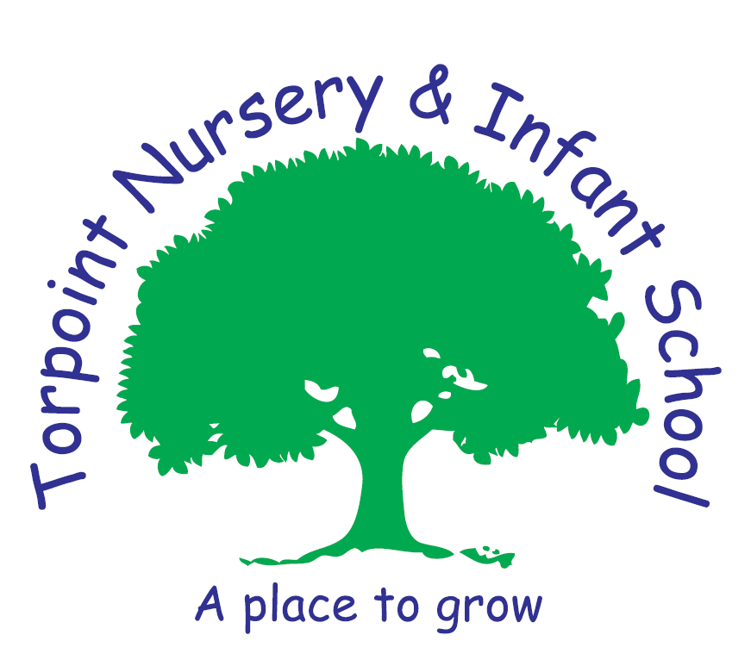
Where each child is special and every child matters
Home School Agreement
We know that clear communication between home and school builds a positive partnership with parents and enables children to make the best progress whilst they are in our care. Our open door policy means that the Head Teacher and class teachers are available and more than happy to talk to you about your child.
This home school agreement helps your child, you as parents and us as a school, to all understand our responsibilities towards each other.
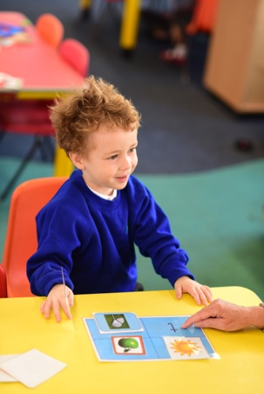
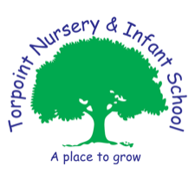
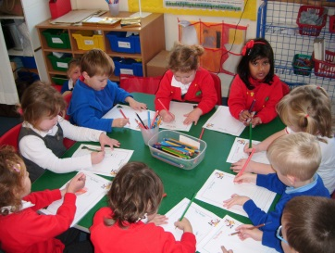
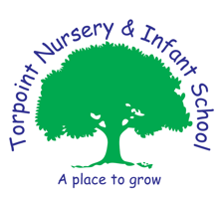
Be kind
Be polite
Play nicely in the playground
Be happy and excited about our learning

We asked our children what they need to do to be successful learners

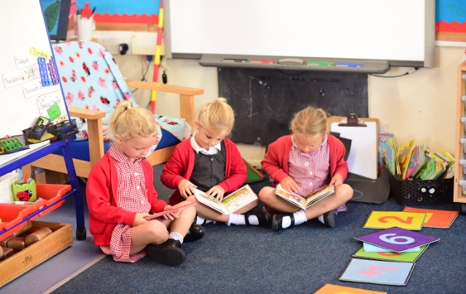
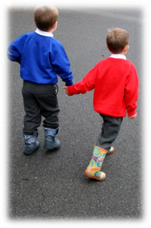
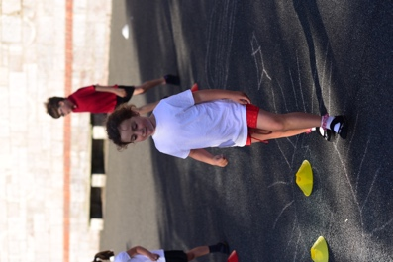
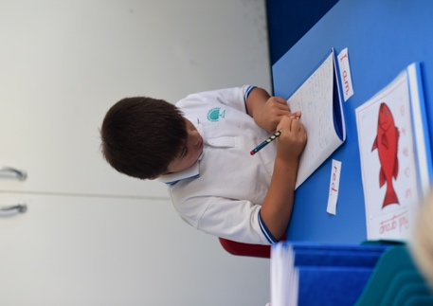
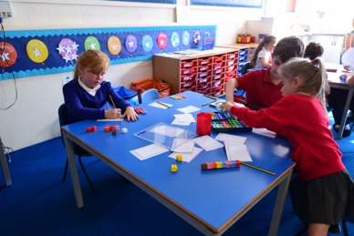
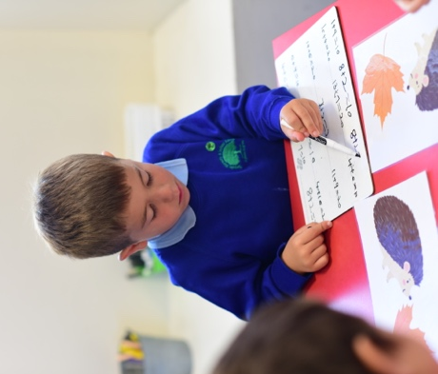
Enjoy learning and have fun
Concentrate
Make each other happy
Our curriculum explicitly teaches children what constitutes socially acceptable behaviour and encourages and reinforces good behaviour. We help children learn to become confident individuals who are able to live safe, healthy and fulfilling lives.
Through our own behaviours toward each other and the children, we help children to become responsible citizens who make a positive contribution to society and who understand their responsibilities as well as their rights.
Share things
We work hard to ensure that the curriculum offered to the children is “What is right for this child in this place at this time”
The curriculum draws on the interests of each child. At the start of every theme the mind maps that the children make enable teachers to understand what the children already know and what they are interested in learning. In this way the curriculum ensures that children are motivated and engaged in their learning.

“Be brainy”
Learning activities are arranged to help all
learners meet the aims of our curriculum and to achieve well.
We understand the different ways in which children learn.
We use a range of methods and approaches to fit the needs of learners.
Be independent
We provide a learning environment that helps children concentrate and persevere with their activities.
In all aspects of school life we focus on creating opportunities for children to be independent and to make their own choices.

Listen to each other

